GlasfaserPlus Telekom

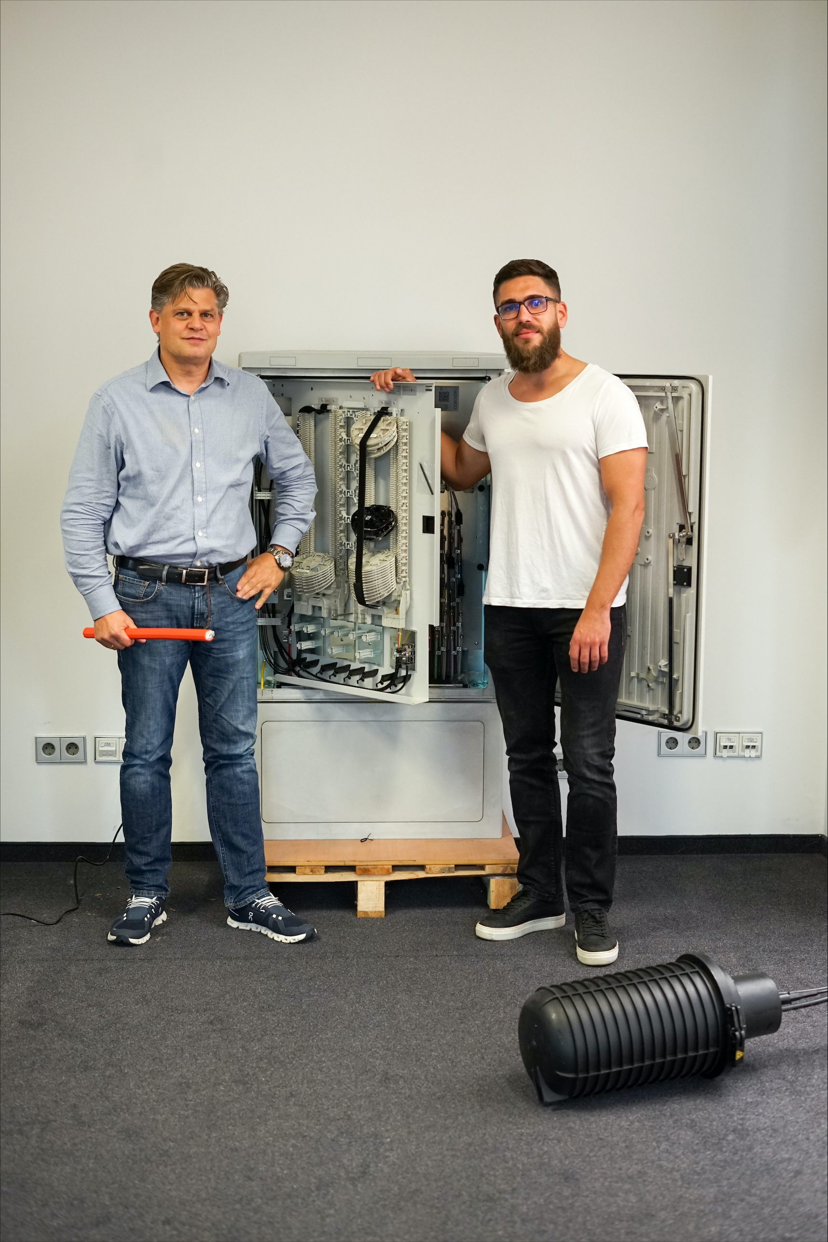

Copyright @ GlasfaserPlus

Bildunterschrift (vlnr):

Jens Olaf Berwig, Chief Commercial Officer GlasfaserPlus
Henrik Bär, Area Manager GlasfaserPlus

